**Provide Insights to the Revenue Team in the Hospitality Domain**

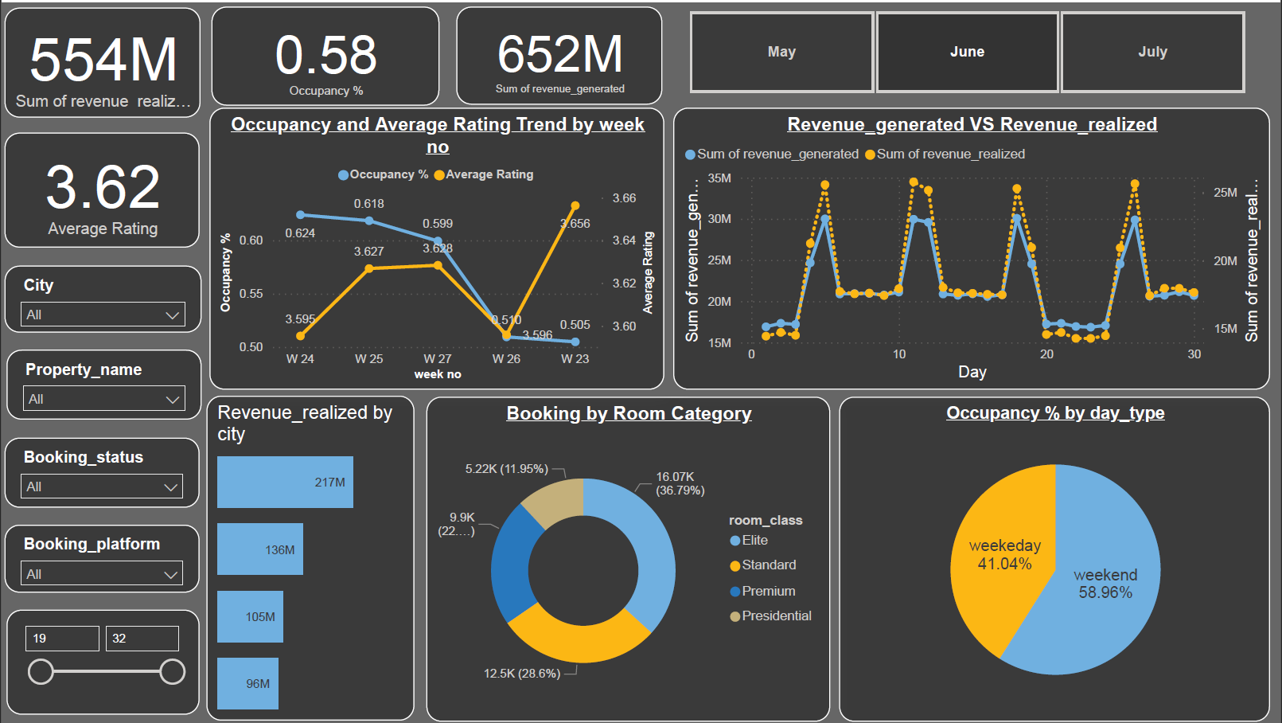

**Problem –**

AtliQ Grands owns multiple five-star hotels across India. They have been in the hospitality industry for the past 20 years. Due to strategic moves from other competitors and ineffective decision-making in management, AtliQ Grands are losing its market share and revenue in the luxury/business hotels category. As a strategic move, the managing director of AtliQ Grands wanted to incorporate “Business and Data Intelligence” to regain their market share and revenue. However, they do not have an in-house data analytics team to provide them with these insights.  
  
Their revenue management team had decided to hire a 3rd party service provider to provide them with insights from their historical data.

**Task –**

You are a data analyst who has been provided with sample data and a mock-up dashboard to work on the following task. You can download all relevant documents from the download section.

1. Create the metrics according to the metric list.
2. Create a dashboard according to the mock-up provided by stakeholders.
3. Create relevant insights that are not provided in the metric list/mock-up dashboard.

**Tools used –**

1. **SQL** – to clean perform ETL on the given data and to get find the insights.
2. **Power Bi** – to create all the interactive visuals for the insights.

**Important notes about Meta data** –

**revenue_generated**: This column represents the amount of money generated by the hotel from a particular customer.

**revenue_realized**: This column represents the final amount of money that goes to the hotel based on booking status. If the booking status is cancelled, then 40% of the revenue generated is deducted and the remaining is refunded to the customer. If the booking status is Checked Out/No show, then full revenue generated will goes to hotels.

**Occupancy** **%**: Occupancy means total successful bookings happened to the total room available (capacity).

**Average Rating**: Get the average ratings given by the Customer.

**Insights** –

1. Sum of revenue_generated was unexpectedly low on Monday, January 31, 2022. It had a value of 41619450, which is outside the expected range of 44131247-80911698.
2. Sum of revenue_generated was unexpectedly low on Monday, January 31, 2022. It had a value of 41619450, which is outside the expected range of 44131247-80911698.
3. Sum of rev generated - Overall Sum of revenue_generated is currently at 2007546215. 1 segments have significantly lower Sum of revenue generated than others, and 1 segments have significantly higher Sum of revenue_generated.
4. AVERAGE RATING - Overall Average Rating is currently at 3.62, and Average Rating for property _name Atliq Seasons is significantly lower than other segments at 2.29.
5. OCCUPANCY - Overall Occupancy % is currently at 0.58, and Occupancy % for property name Atliq Seasons is significantly lower than other segments at 0.45.
6. Mumbai is the only city that comes on top in case of revenue generation. It also has a consistent rating in all the hotels and there is a huge drop of occupancy on week 23.